Planetary Bean Bouncer – Mechanical Build Guide

Before you begin:
- Review the full guide once before assembling.
- Print Test_1.stl to verify hole tolerances for screws, nuts, and bearings.
- Print Gearing_5_1_16_24_64_Test_Rev36.stl to test planetary gear meshing (can be used as a fidget after printing).
- Verify you have all hardware listed in the BOM.
- Do not fully tighten fasteners until shaft alignment is confirmed.

This guide documents the mechanical assembly of the Planetary Bean Bouncer coffee roaster. Electronics wiring and configuration are not covered in this document and will be addressed in a separate guide.
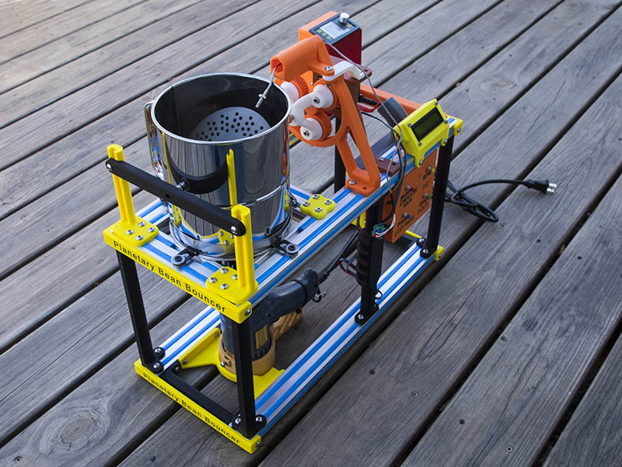
Frame
The aluminum extrusion part of the frame consists of 4-2040x500mm and 2-2040x140mm V-Slot extrusion. You should also be able to substitute T-Slot 2040 if you prefer, but I have not tested those. I am using 74 Tee Nuts and all the 3D printed parts are sized to use M5x12mm screws. I use 18-8 stainless steel button head screws as I prefer them. Anything outside the sifter does not need to be stainless though. You might have less or more of these Tee Nuts depending on how you configure it. For instance, you will probably power the 12 V supply for the motor differently than I do or you might not want to bother with the planetary gear system.
We will start with building the bottom frame. For the bottom frame we start by assembling V2040_Bot_Connect_1 (1st part of 2040_Bot_Connects.stl) and the Heatgun_Center_V2 3D prints. If you are using a different heat gun than in BOM, this probably will not work for you. The Heat gun center part is not necessary but makes it easy to line up the heat gun if you are using the same heat gun I have listed in BOM. You need 4-M5x12mm screws with Tee Nuts for the Heat gun center part and 2-M5x12mm screws with Tee Nuts for the V2040_Bot_Connect_1
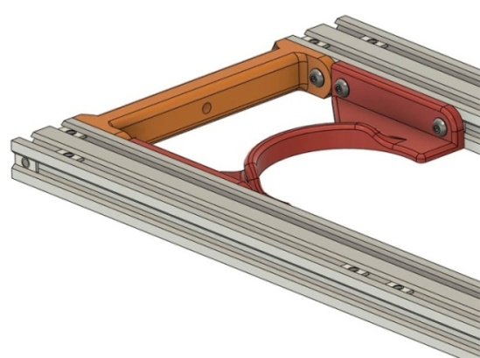

Connect V2040_Bot_Connect_2 (2nd part of 2040_Bot_Connects.stl) at each end of the frame with 2-M5x12mm screws and Tee Nuts like the other end.
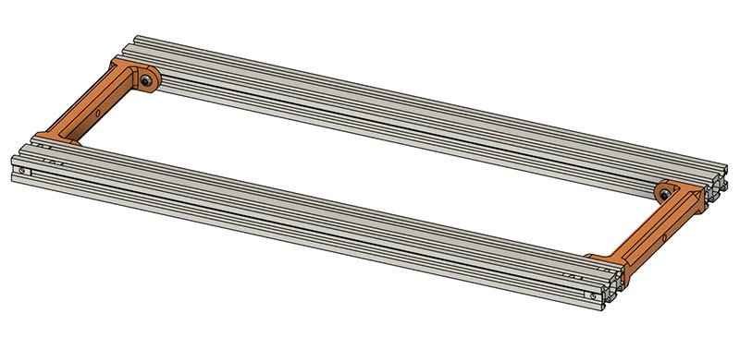Add V2020_Column_1 (1st part of 2020_CornerColumns.stl) to the front corner below where sifter will be using 2-M5x12mm screws. These columns are slightly different because of print orientation, but essentially any of the 4 can go in any corner.
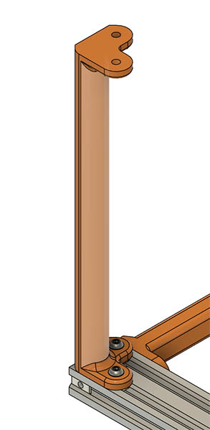
Add V2020_Column_2 (2nd part of 2020_CornerColumns.stl) to opposite short side using 2-M5x12mm screws.
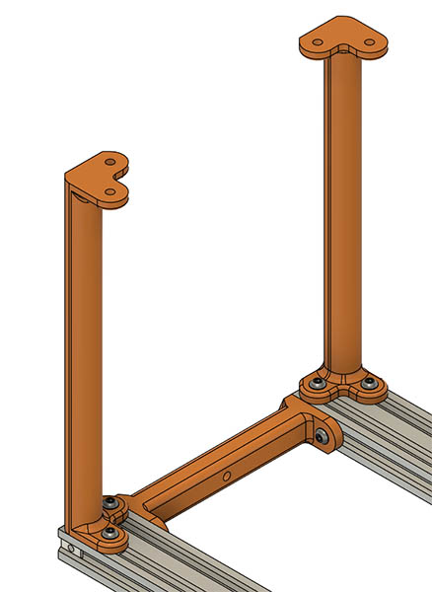
Do the same for the opposite side using 4-M5x12mm screws.
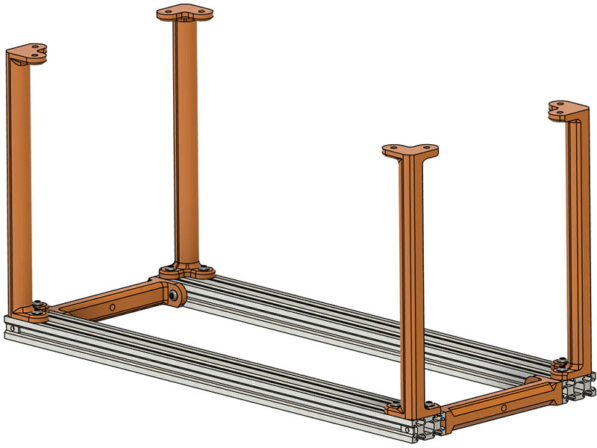
Assemble CenterColumn_1.stl and CenterColumn_2.stl to the bottom frame using a total of 4-M5x12mm screws as shown. They do not necessarily have to go in the middle. I have the back one in the middle for grabbing the center to dump roasted beans, but the front one I have closer to electronics to fasten MAX6675 and wire tie motor wire.
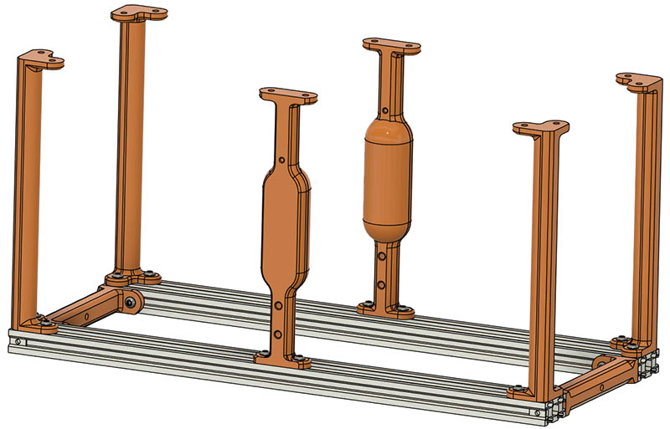
Turn the bottom frame upside down and assemble the 2-2040x500mm lengths to it using 12-M5x12mm screws with a Tee Nut for each screw.
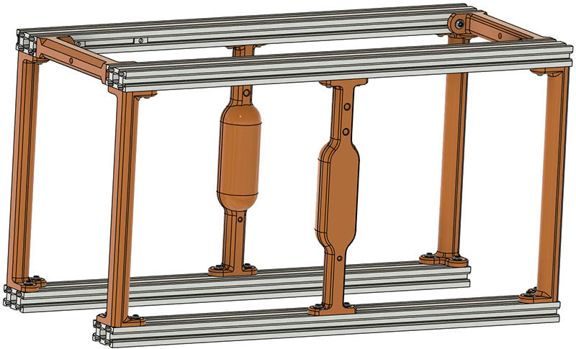

Turn frame right side up again and add 10 Tee Nuts as shown in green to the 2–2040x140mm length extrusions. They do not need to be positioned correctly yet.
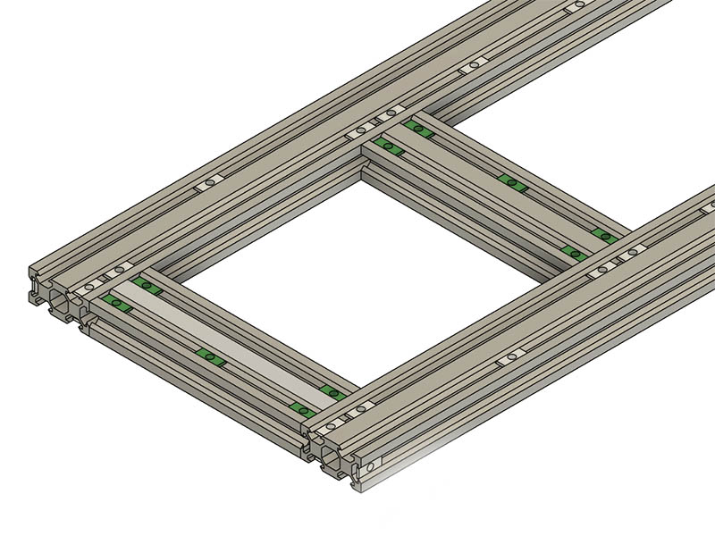
Attach Bearing_Column_1.stl and Bearing_Column_2.stl (from BearingColumns.stl ) to the end of the 2040x500mm top frames and the short 2040x140mm extrusion as shown. Make sure you have a Tee Nut as shown in the middle of short 2040. It does not have to be centered yet. Use 8-M5x12mm screws with Tee Nuts in the extrusions to connect these.
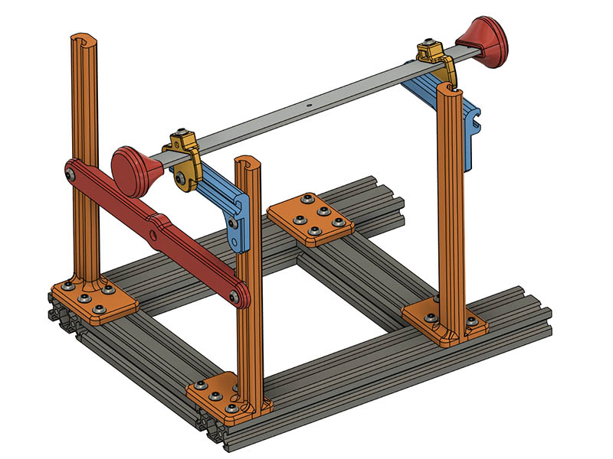

Take the BearingBar.stl (from BearingColumns.stl ) 3D print and insert a 625-2RS into it as shown here.
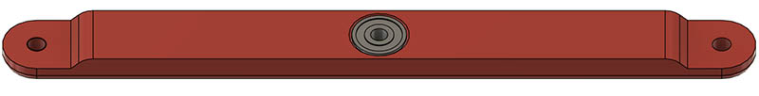

I created a plate of the STL files for this assembly. I count 25-M5x12mm screws, 23-M5 T-Nuts and 2-M5 Locknuts. The light blue part has a place for another screw, but not really needed since the back profile matches V-Slot and holds well enough with that.

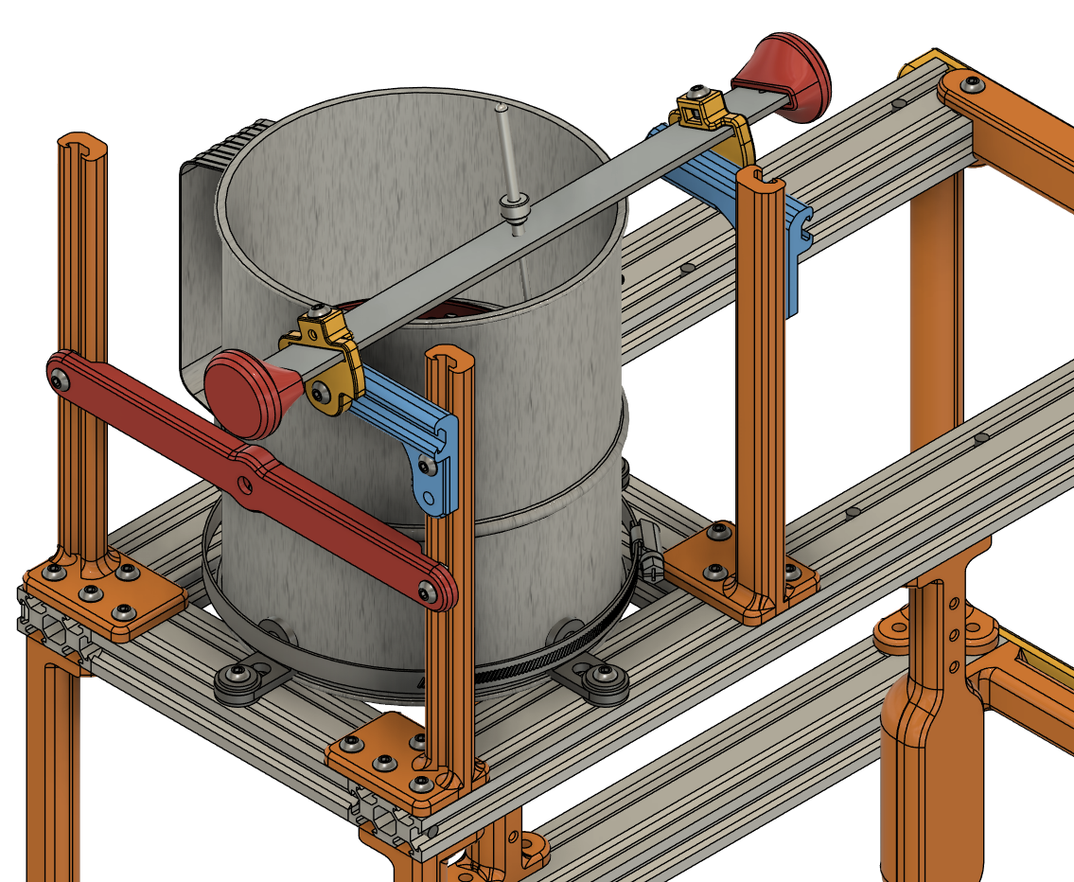

Add the ShortV_Connect_V3.stl before putting the end piece on. This is used for connecting the Electronics case to the extrusion. If you are putting together the Arduino UNO case I made, you may want to attach the case and LCD case to this before attaching to the 2040 extrusion.

The next part to install is the V2020x140_Mod.stl 3D print. You could also use a 2020x140mm length of extrusion, but this uses only 1 Tee Nut on each side and you do not have any grooves for chaff to get in.
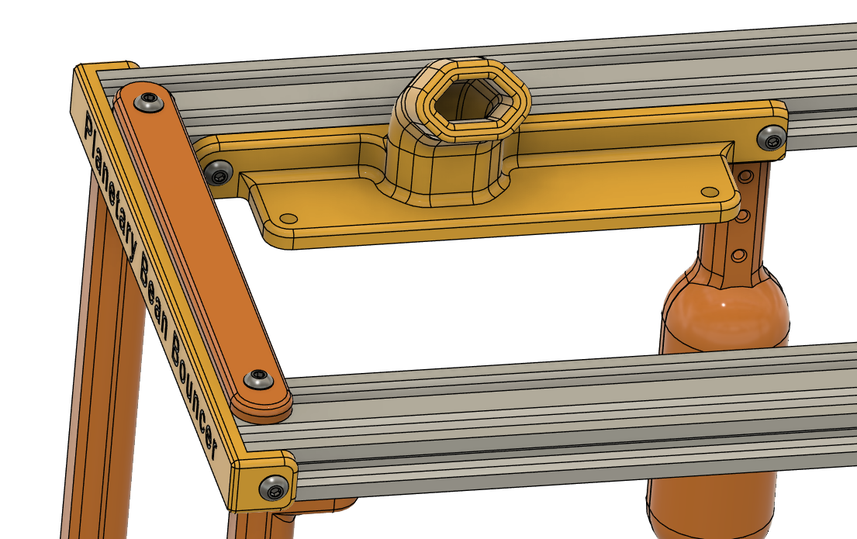

Except for putting the end caps on this completes the top frame construction. I would not put them on until the end in case you need to insert some Tee Nuts somewhere you missed. Only the 2 Tee Nuts in the short 2040x140mm extrusion need to be in there at this point. The others are easy to put in when you need them until the endcaps go on.
Optional 5:1 Planetary Gear
Below is an exploded view of the planetary gear system if you choose 3D printed instead of purchased planetary gear. I am only showing the hardware for 1 planet to simplify the view.
Hardware:
Planet connection hardware:
3 – M5x30mm button head screws
6 - 625-2RS bearings
3 – M5 Shim washers (flat washers will probably also work)
3 – M5 Locknuts
Shaft Connection hardware:
2 – M4x25mm Tap Bolts
2 – M4 Lock washers
2 – M4 Locknuts
2 – Brass Hex Coupler 5mm bore and M4 threads on Hex end

2040 Connection hardware:
2 – M5x12mm screws
2 – M5 Tee Nuts
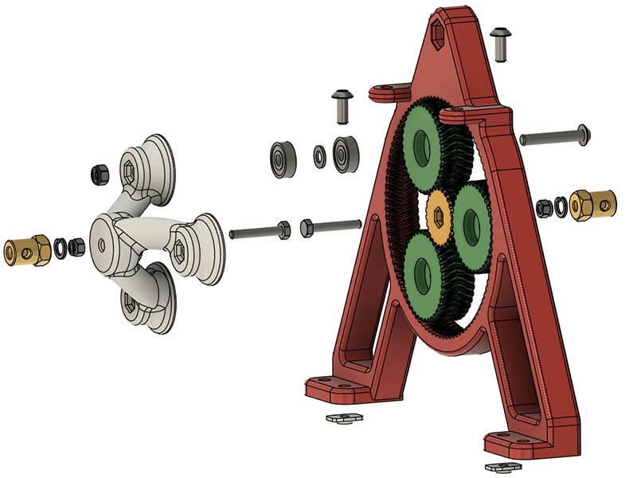

Insert a M4x25mm tap bolt through the bottom of the PlanetDrive_5_1_Rev35.stl shown in white, Tighten M4 Locknut down on top of Planet drive and add a lock washer on top then thread the brass hex coupler down tight.
Insert the other M4x25mm tap bolt through the top of the sun shown in yellow. Before adding all that hardware, we want to add all the planet bearings as it will be easier. Add the 3 – M5x35mm screws (30mm length might work) through the bottom of each planet. While holding them in place with your fingers, place this gear system on a flat surface. Put a 625-2RS inside the top of each planet followed by M5 shim washer and bearing. I included M5_Bearing_Shims.stl you can probably use in place of the M5 shim washers. Place the PlanetDrive_5_1_Rev35.stl on top of the bearings. The M5x30mm screws should protrude through the top. Add a M5 locknut to each and tighten them all the way down, then loosen each M5x30mm screw a little until the gear system turns good. If you had put the M4 hardware on before this, you would not have been able to lay this planetary gear on a flat surface. Now add a M4 locknut down tight on the bottom of the sun and add a lock washer followed by the other brass hex coupler. Tighten the hex coupler all the way down. The M5 end of the coupler behind the sun gear connects to the motor and the other one connects to the shaft. The 2-M5x12mm screws and Tee Nuts connect this planetary gear to the top of the 2040 extrusion.

Nema 17 Motor Mount Assembly
Hardware:
Nema 17 connection hardware:
1 – Nema 17 motor (Mine is a 0.9 degree 40mm deep specified in BOM)
4 – M3x10mm screws

2040 Connection hardware:
2 – M5x12mm screws
2 – M5 Tee Nuts
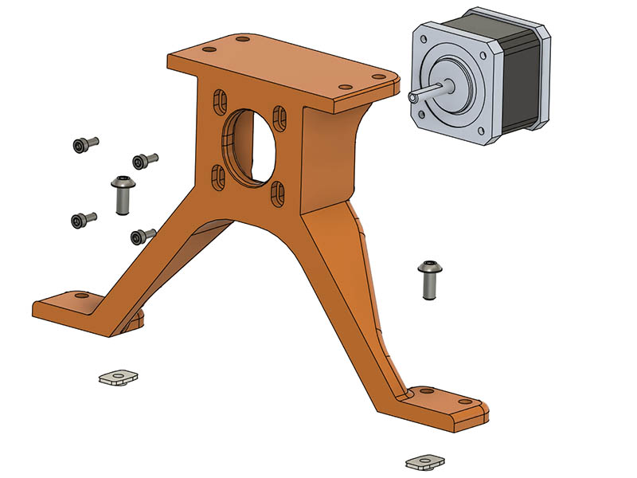

Wobble Disc Assembly with shaft
If you cut your own disc out of stainless steel sheet, your hardware will be different. Whatever method you use, I would recommend 3d printing WobbleDisck_Mount_JamNuts.stl out of PLA first to check the diameter size. Print it on a 45 degree angle and add manual tree support between bottom and mid-section. My disc ended up being about 5.14” or 130.175mm which is the size of that .stl file.
Hardware:
1 – 316L 3D Printed Stainless Steel Wobble disc
1 – M5x200mm fully threaded 18-8 stainless steel shaft (18-8 = 304 SS)
2 – 18-8 Stainless Steel External Tooth Lock Washers
4 – Regular M5 hex nuts (4mm thick to better get wrench on)
4 – M5 Serrated Flange Lock Nuts.
2 – M5x10x18mm 18-8 Stainless Steel Spacers
Only the 2 external tooth lock washers, 2 hex nuts, and 2 serrated flange lock nuts are really necessary. I added the spacers with hex nut, flange nut to cover the threads more. Using more spacers will make it more difficult to put the shaft in. I also recommend drilling out the shaft openings with a 3/8” cobalt drill bit so the shaft does not ride on the sifter at all. That larger hole also allows you to thread all the hardware on outside the sifter. I left about 15mm of the shaft on the outside bearing side and 31mm on the drive side. The coupling on the drive shaft side has 2 set screws 180 degrees apart, so I also filed down the shaft on the drive side on 2 sides so coupling gets better grip.
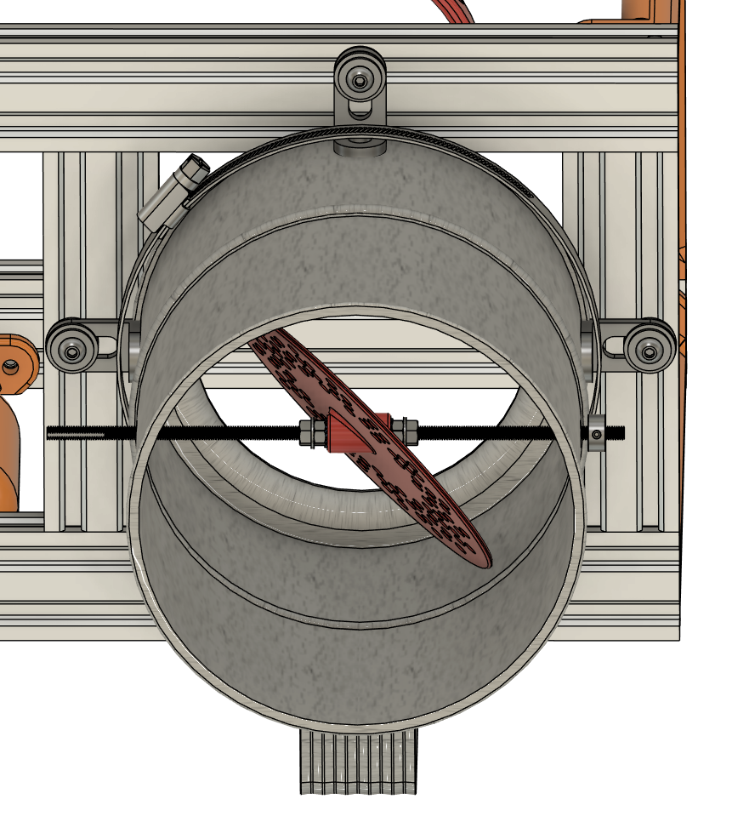

Mount Flour Sifter Assembly to Frame
Hardware:
1 – Assembly from previous procedure
1 - 5"-7" SS Band Clamp
4 – 18x18x30 L Brackets as shown in BOM
4 – M5x12mm screws
4 – Tee Nuts
12 - M5 fender washers as shown in BOM

Mount as shown in graphic below.
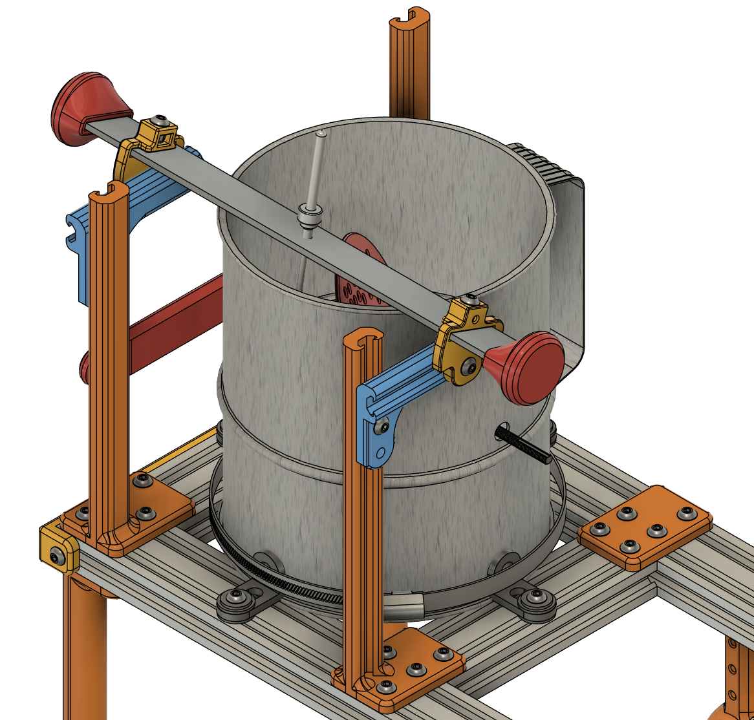

Mount Planetary gear assembly and Motor Mount Assembly
Hardware:
4 – M5x12mm screws
4 – Tee Nuts

Now add the planetary gear assembly and motor mount assembly. There are 2 extra mounting holes on both the planetary gear and motor mount, but since they are tied together I only use one screw on each side of the mount as shown.

To get the motor to correct height, use HexAdapter_Height_Shim.stl between the top of the 2040 extrusion and the bottom of a flat side of the hex coupler. Loosen the screws on the motor mount and adjust to fit on top of that shim. It will probably be center of the slot opening on the mount.

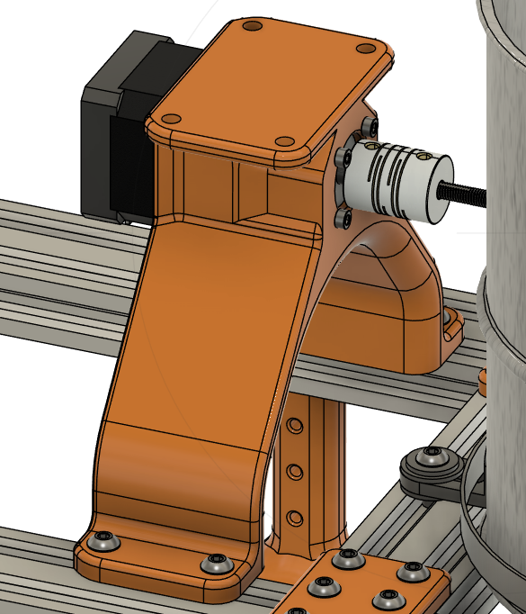

End Cap Assembly
4 – 3D printed End caps
8 – M5x12mm screws
8 – M5 Tee Nuts.

Add the End Caps as shown. They will be the same on both ends
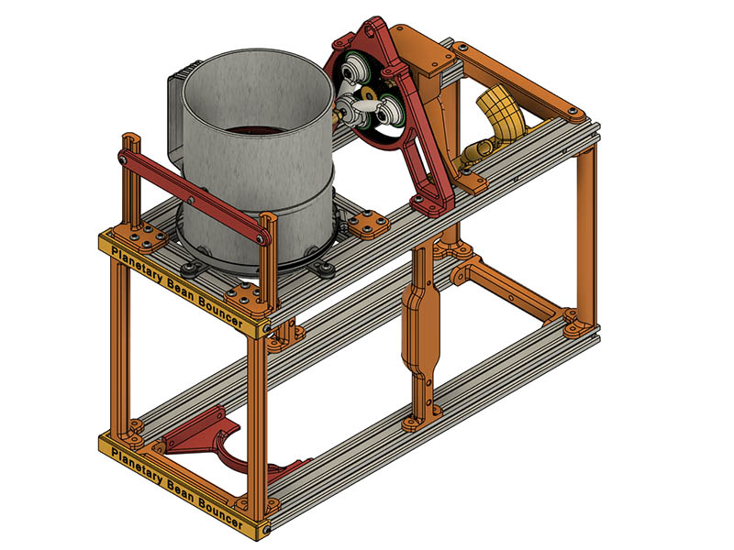
This completes the frame and mechanical build.

